2025 
Application Form
* Country | Vietnam / Sector : North
* Inventor(s) & Participant Information | Name |  | School / Company Name
* Inventor(s) & Participant Information | - Chau Hong Nhat Linh |  | Tran Dai Nghia High School for the Gifted
* Inventor(s) & Participant Information | - Chu Hoàng Chau Anh |  | Tran Dai Nghia High School for the Gifted
* Inventor(s) & Participant Information | - Tran Gia Minh Tam |  | Vinschool golden river
* Inventor(s) & Participant Information | Note: Up to 5 participants per team. Ensure names and affiliations are accurate as they will appear on official certificates.
* Participation Type | On-Site |  | Online
* Participation Type | x
* Contact Information  (Advising Teacher  or Team Leader) | Name | Nguyen Thi Dung
* Contact Information  (Advising Teacher  or Team Leader) | Title(e.g., Teacher) | Teacher
* Contact Information  (Advising Teacher  or Team Leader) | Tel | +84935358270
* Contact Information  (Advising Teacher  or Team Leader) | E-mail | thuydung9810@gmail.com
* Note: Additional documents, if required, will be requested by the organizing team.

Send to: Lee37895661@gmail.com

Date: 2025,

* Name of  Invention | Polyphenol extraction from cashew testa and development of a topical antioxidant functional product
* Abstract  of Invention  &  Photo of  Invention | 1. Introduction:  Vietnam has remained the world’s leading exporter of cashew nuts for 18 consecutive years, accounting for over 80% of global export volume. In 2024 alone, the country exported more than 765,000 tons of cashew kernels, generating over 4.6 billion USD in revenue - a remarkable increase compared to previous years. Binh Phuoc Province, often referred to as the “cashew capital” of Vietnam, contributes nearly 50% of the national cultivation area and over 40% of the total raw cashew nut output.  Despite the industry’s robust growth, large quantities of cashew testa- the thin, reddish-brown skin surrounding the kernel - are commonly discarded or used as low-value fuel or fertilizer. However, cashew testa is rich in bioactive compounds, including polyphenols, tannins, catechin, epicatechin, and gallic acid, which have been scientifically reported to exhibit antioxidant, anti-inflammatory, antimicrobial, and anti-allergic activities. This highlights the testa’s potential as a valuable but underutilized resource in fields such as pharmaceuticals, cosmetics, and food technology.  This study aims to extract a polyphenol-rich fraction from cashew testa and evaluate its potential in the formulation of an antioxidant topical cream. Ultrasound-assisted extraction (UAE) was employed using various solvent systems to enhance extraction efficiency and bioactivity. Compared to conventional methods, UAE offers multiple advantages, including reduced processing time, broad solvent compatibility, and improved operational safety. Through this work, we seek to promote the valorization of agricultural by-products while contributing to sustainable development and the creation of high-value natural products.  2. Objectives:  The objective of this study is to sustainably valorize cashew testa by extracting its bioactive polyphenols and developing an eco-friendly antioxidant cream, thereby promoting green innovation, functional product development, and responsible agricultural waste utilization..Specifically, the study aims to:  (1) extracting polyphenols from cashew testa using green methods;  (2) evaluating their antioxidant and antimicrobial activities;  (3) developing a natural, eco-friendly skincare product;  (4) promoting responsible waste utilization and climate awareness.  3. Experimental:  1. Extraction of Cashew Testa Polyphenol-rich Extract  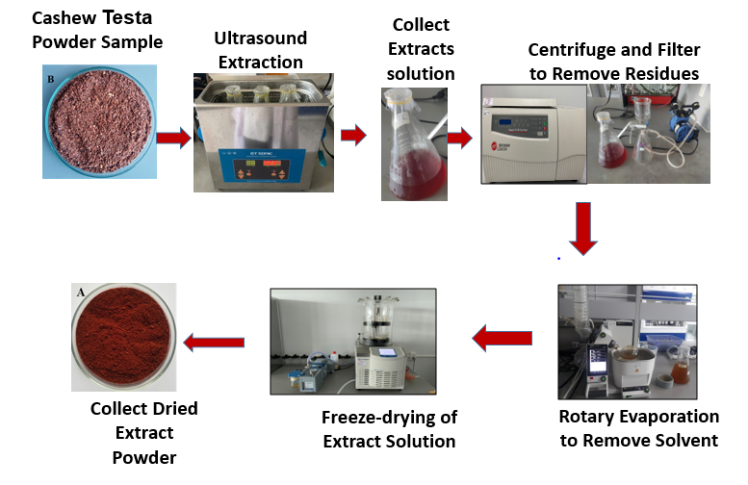  Figure 1: Extraction process of Cashew Testa  Collected cashew testa was pretreated to remove impurities and dust, then dried at 50°C and ground into fine powder. Extraction was performed using ultrasound-assisted extraction (UAE) with various solvents (ethanol, methanol, and water), under different conditions of time, temperature, and solid-to-solvent ratios. Extraction efficiency was evaluated based on yield and total polyphenol content (TPC), expressed as mg GAE/g extract.  2. Determination of Total Polyphenol Content (TPC)  TPC was determined using the Folin–Ciocalteu method, with results calculated from a standard calibration curve.  Evaluation of Biological Activities  3.1. Antioxidant Activity  Antioxidant capacity was assessed using DPPH and ABTS radical scavenging assays. Inhibition percentages and IC₅₀ values were determined.  3.2. Antibacterial Activity  The antibacterial effect of the extract was evaluated against Staphylococcos aureus ATCC 25923 and Candida spp, using disk diffusion and minimum inhibitory concentration (MIC) methods.  4. Cream Formulation  The cashew testa extract was incorporated into a topical cream formulation. The final product is a homogeneous, brown-colored cream, packed in 10g aluminum tubes, with smooth texture and no phase separation.  4.Results and discussion  4.1. Extraction Yield of Cashew Testa Extracts  Different extraction solvents (ethanol and methanol, water) were applied using ultrasonic-assisted extraction. The results are summarized below:  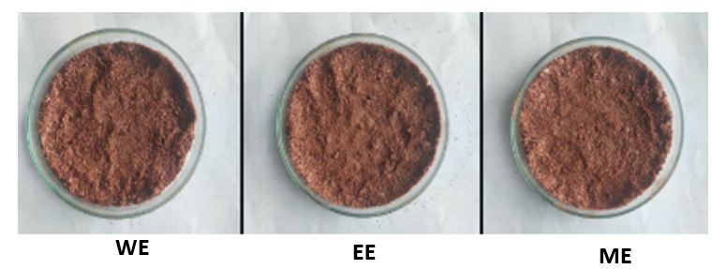  Figure 2: Photos of cashew testa extract powder from different extraction solvent  Table 1: Extractuon efficiency (%) of Different extraction solvents  Values in the same column followed by different letters are significantly different at the 95% confidence level, as determined by Tukey’s test  4.2. Phytochemical Screening and Polyphenol Content  Qualitative Results: Qualitative phytochemical screening of the cashew testa extracts revealed the presence of key natural compounds, including phenolics, tannins, and flavonoids, in all three extract samples.  Table 2: Qualitative phytochemical screening of the cashew testa results of some natural compounds inthe cashew testa extracts samples  All of extract samples contained natural compounds such as coumarin, phenolic, tannin, and flavonide, as shown in Table 2.  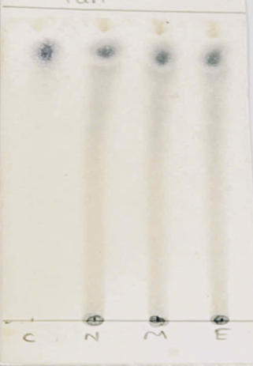  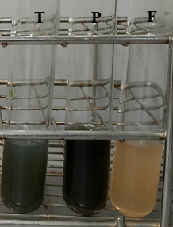  Control  WE  ME  EE  Polyphenol  A  B  Figure 3: Qualitative Results (A. TLC method. B. biochemical reaction)  4.3 Total Polyphenol Content  The methanol extract exhibited the highest total polyphenol content (484.06 mg GAE/g extract), followed by ethanol (465.33 mg GAE/g extract) and water extract (453.13 mg GAE/g extract). Differences may result from the chemical structure and polarity of individual polyphenols.  Table 3. Total Polyphenol Content of Extracts  Values in the same row followed by different letters are significantly different at the 95% confidence level, as determined by Tukey’s test  4.4. Antioxidant activity  DPPH radical Scavenging activity (%)  The DPPH radical scavenging activity of the cashew testa extracts from 7.61% to 88.56%. IC₅₀ values were 13.72 mg/mL (ethanol), 13.07 mg/mL (methanol), and 14.68 mg/mL (water). Notably, no significant differences were observed in the radical scavenging percentages between the extracts and the positive control (vitamin C) across the tested concentrations.  Figure 4: DPPH Radical Scavenging Activity (%) of the Extracts  Table 4: IC50 value of the extracts  ABTS Radical Scavenging activity (%)  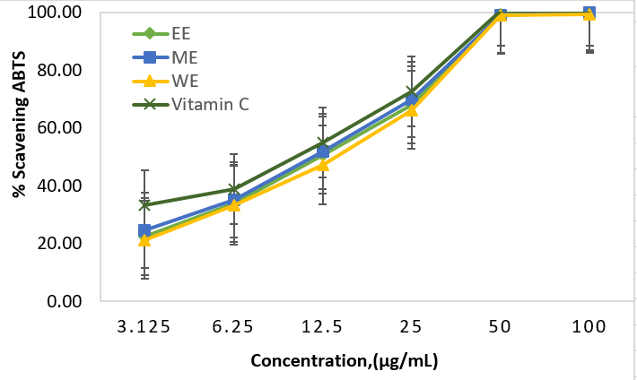  Figure 5: ABTS Radical Scavenging Activity (%) of the extracts  The ABTS radical scavenging activity of cashew nut shell extracts ranges from 21% to 99,79%, with IC₅₀ values ​​of 10.17 µg/mL for the methanol extract, 10.34 µg/mL for the ethanol extract, and 11.36 µg/mL for the water extract. Although all extracts demonstrated notable antioxidant potential, their activities were lower than that of Vitamin C. Importantly, no significant difference in radical scavenging capacity was observed between the ethanol and methanol extracts.  Table 5: IC50 value of the extracts  4.5. Antibacterial Activity  Antimicrobial tests against Staphylococcus aureus and Candida albicas showed the ethanol extract exhibited inhibitory zones, demonstrating promising antibacterial potential  .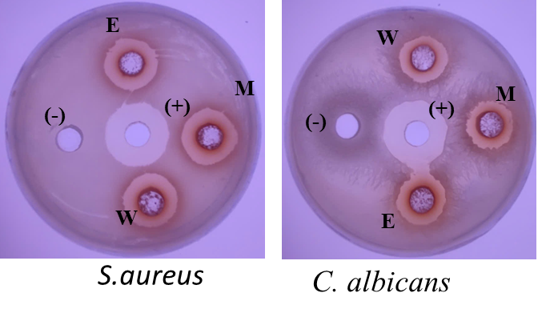  Figure 6. Antibacterial activity results of cashew testa extraction by dish diffusion  The results demonstrated that all three cashew testa extracts exhibited inhibitory effects against both tested microbial strains, with ethanol and methanol extracts showing the most pronounced activity, as indicated by inhibition zones exceeding 11 mm. The minimum inhibitory concentration (MIC) agains Candida albicans and Staphylococcus aureus was 1.56 mg/mL for both ethanol and methanol extracts.  Table 6: IC50 value of the extracts  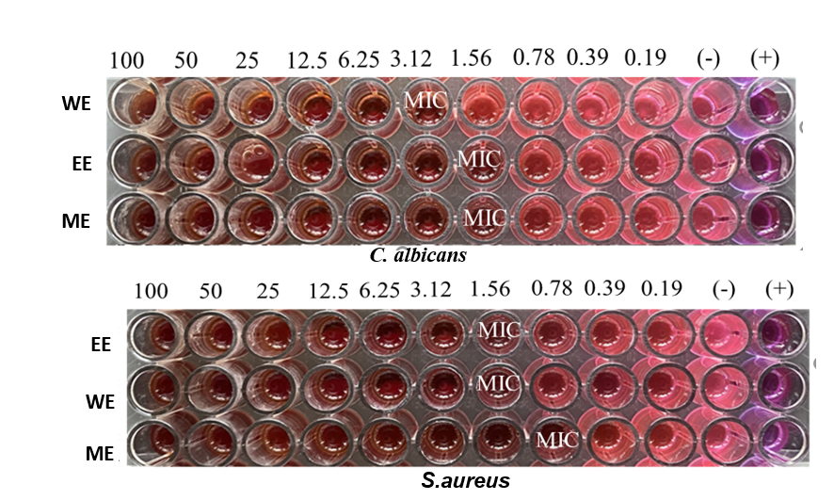  Figure 7. Minimum inhibitory concentration (MIC) results of the extracs.  Finally, the results indicated that both ethanol and methanol extracts exhibited the highest biological activities. Ethanol extract was selected for cream formulation due to its slightly higher polyphenol yield and bioactivity, as well as its lower toxicity and greater suitability for topical applications compared to methanol. Moreover, ethanol is a safer, food-grade solvent that complies with green chemistry principles and regulatory standards for cosmetic product development.  4.6 Cream Formulation  The cashew testa extract was incorporated into a topical cream formulation. The final product is a homogeneous, brown-colored cream, packed in 10g aluminum tubes, with smooth texture and no phase separation.  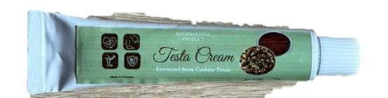  Figure: Cashew testa cream  5. Conclusion:  The findings of this study demonstrated that cashew testa extracts possess a high polyphenol content and exhibit strong antioxidant and antimicrobial activities. Based on these properties, a stable and natural topical cream was successfully formulated, highlighting the extract’s potential for practical application in cosmetic products. This research contributes to the sustainable valorization of agricultural by-products and supports the development of eco-friendly innovations in both agriculture and the skincare industries.
  Sample | Input mass  (g) | Extract yield (g) | Extraction efficiency (%)
  EE | 10 | 2.65 | 26.53^{b} ± 2.87
  ME | 10 | 3.61 | 36.07ª ± 1.7
  WE | 10 | 1.55 | 15.47^{c} ± 0.31
  Sample | Tannin | Flavonoid | Polyphenol
  EE | + | + | +
  ME | + | + | +
  WE | + | + | +
  Sample | EE | ME | WE
  Total polyphenols (mg GAE/g extract) | 465.33^{b} ± 4.69 | 484.06ª ± 4.26 | 453.13^{c} ± 0.65
  Sample | Equation | IC50 value  (µg/mL)
  EE | y=22.787ln(x) - 9.674,, R²= 0.9683 | 13.72
  ME | y=22.451ln(x) - 7.7085, R²= 0.9759 | 13.07
  WE | y=23.913ln(x) - 14.249, R²= 0.9607 | 14.68
  Vit C | y = 22.05ln(x) - 3.6337, R² = 0.9603 | 11.39
  Sample | Equation | IC50 value (µg/mL)
  EE | y= 24.282ln(x) - 6.9244,R²= 0.9545 | 10.43
  ME | Y = 23.646ln(x) - 4.7629,R²= 0.9462 | 10.14
  WE | y= 24.956ln(x) - 10.874,R²= 0.9526 | 11.36
  Vit C | y=22,245ln(x) + 2,8521 R² = 0.9535 | 8.32
  Sample | Diameter of inhibition zone of S.aureus (mm) | Diameter of inhibition zone of C.albicans (mm)
  Ethanol | 12,5ª ± 0,5 | 11,17ª ± 0,29
  Methanol | 13,5ª ± 0,5 | 11,33ª ± 0,58
  Water | 11,17^{b} ± 0,29 | 10,5ª ± 0,5

